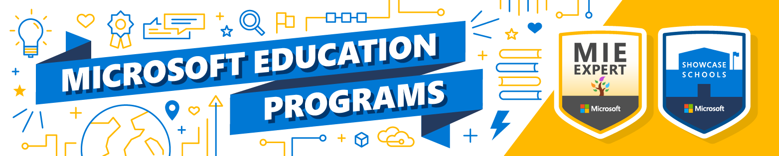

Microsoft Innovative Educator (MIE) Expert nomination questions
Notice: MIE Expert self-nomination window will be May 15, 2022 – July 7, 2022
Below are the questions that you will be asked during the nomination process. They are broken into three sections (but all are done at the same time). Announcements will be made the week of August 15, 2022 (Pacific Time).
Definitions:
- The term educator refers to classroom teachers, school leaders, professional learning specialists, instructional assistants, trainers, or anyone who supports teaching and learning and wants to grow their skills and support others.
- The term learner refers to anyone who is receiving instruction from you. Examples are adults that you are training, students in a classroom, or colleagues that you work with that you are training.
HINT – It is perfectly OK to work with other colleagues as you prepare your nomination! For Phase 2 questions, use the resources below to find the answers before you nominate yourself at https://aka.ms/EDUNomination. Make it fun and do it with some of your colleagues! This is NOT cheating! 😊
Three parts of the nomination form:
- About you (this is simply so we know who you are. If you use other tools/devices and are members of other communities from other tech companies, we are happy to have you in our community!) This section does not impact your nomination in any way.
- Scored questions on using Microsoft Education tools (these will be scored automatically, and you must reach a certain level to be moved on to the human review phase).
NOTE: If you do not pass this section, you will be notified via email. At that time, you will need to cancel your nomination and create a new nomination to be re-scored.
- Long form questions that will be reviewed by your local Microsoft team (in your country/region) – Your final submission must be received by end of day on July 7 (Los Angeles/Seattle Time) – These questions will be reviewed and is the most important section. We suggest that you have a colleague review your responses. You may respond in your native language! You must respond with more than 500 characters (not words) and less than 2500. We want detailed responses that fully answer the questions.
Below the questions on this document, you’ll see links to MEC courses that can help you prepare if you aren’t familiar with Teams, OneNote, Forms, and other Microsoft Education tools.

About You
* First: ________________________________
* Last: ________________________________
* Personal email: ________________________________
* School/organization email: ________________________________
* Home address (shipping address) ________________________________
* School/Institution/Organization address ________________________________
* School/Institution/Organization website ________________________________
* What is your title: ________________________________

* Current role at school/organization (check all that apply):
- I am directly responsible for teaching K-12 students.
- I am responsible for or teach STEM at my school/system.
- I am involved in curriculum development.
- I am an education trainer (professional development specialist)
- I am a school leader or administrator.
- I am a higher education faculty member.
- I am a Dean in a higher education institution.
- I am a student enrolled in a college of education of a pre-service teacher.
- I am a chief information officer or set policy and make decisions about the technology infrastructure schools in my area use.
- I am a government leader or set educational policy at a local, regional or country level.
- Other ____________________________

* Is your school a Showcase School, Incubator School or neither?
- Showcase School
- Incubator Schools
- Neither

* If Showcase: There will be a dropdown of all Showcase Schools. Select yours.
* If Incubator: There will be a dropdown of all Incubator Schools. Select yours.

* If Neither: Enter the name of your school/organization: __________________________

* What age range do you teach (select all that apply)?
- 0 – 5 years old
- 6 – 8 years old
- 9 – 11 years old
- 12 – 14 years old
- 15 – 18 years old
- Students over 18 years old
- I am responsible for delivering professional development to teachers.

*What Subject(s) do you teach (select all that apply)?
- General (Primary)
- Reading/Writing/Literature
- Mathematics
- Science
- History
- Geography
- Foreign languages
- Design and technology
- Art and design
- Music
- Physical education
- Computing
- Other (short answer)

* Do your students/learners have access to internet at school?
- Yes
- No
- N/A (I don’t work directly with students)

* Do your students/learners have access to internet at home?
- Yes – all of them do
- Yes – some of them do
- No – none of them do
- N/A (I don’t work directly with students)

* What technology do your students/learners primarily use for learning (check all that apply)
- Mobile phone
- Laptop/Chromebook
- Tablet
- Shared device
- My students/learners don’t have access to a device.

Share the URL to your social handles (if you have them):
- Twitter Handle _________________
- Facebook handle _________________
- Instagram: _________________
- LinkedIn: _________________
- TikTok: _________________
- YouTube Channel: _________________
- Blog: _________________
- Other: _________________

How many followers do you have on Twitter: __(number)___

* What tools/devices do you use regularly (check all that apply)?
- Google Apps
- Chromebooks
- iPad
- Macbooks
- Windows Devices
- Microsoft Surface
- Microsoft 365
- Microsoft Teams
- Zoom

* What tools/devices does your school/organization use (check all that apply)?
- Google Apps
- Chromebooks
- iPad
- Macbooks
- Windows Devices
- Microsoft Surface
- Microsoft 365
- Microsoft Teams
- Zoom

With what other Ed Tech communities are you connected (check all that apply)?
- Adobe Creative Educator
- Apple distinguished educator
- Buncee Ambassadors
- Flipgrid Student Voice Ambassador
- Genially Ambassadors
- Google Certified Coach
- Google Certified Innovator
- Google Certified Trainer
- Google Educators groups
- HP Fellows
- ISTE Certified Educators
- Kahoot! Ambassadors
- Merge Ambassadors
- Minecraft Global Mentor
- National Geographic Certified
- Nearpod Certified Educator/PioNear
- Peardeck Inspearational Educators
- ScreenBeam Experts
- Wakelet Ambassador

Have you taken any coursework or earned any badges and trophies on Microsoft Learn (http://learn.microsoft.com)?
- Yes
- No
If yes, share the URL to your public profile here: ________________________. You can find your public profile in Learn by clicking your profile circle in the upper right corner of Learn and then selecting “Profile”

Machine-learning scored questions
NOTE: If you do not pass this section, you will be notified via email. At that time, you will need to cancel your nomination and create a new nomination to be re-scored.

* How many modules on the Learn Educator Center have you completed?
- 0-1
- 2-5
- 6-10
- 11-15
- 15-20
- 21-25
- 26 or more

* How often do you…
 | Daily | Weekly | Monthly | Rarely | Never
How often do you use Microsoft Teams in an instructional environment?
Use Microsoft Forms in an instructional environment?
Use OneNote for personal organization?
Use OneNote and/or Staff Notebook for professional organization?
Use OneNote Class Notebooks with learners?
Use Flipgrid with learners?
Use Minecraft: Education Edition with learners?
Share your teaching/learning knowledge with your colleagues

* How often do you use the following STEM resources/tools with learners?
 | Daily | Weekly | Monthly | Rarely | Never
MakeCode
Hacking STEM
Microsoft Imagine Academy (MSIA)

* How often do you use the following features of PowerPoint for teaching/learning?

 | Daily | Weekly | Monthly | Rarely | Never
Live presentations
Record Slide Show (Slide Show tab)
Saving a PowerPoint as a video (Save As)
Rehearse with Coach (Slide Show tab)
Subtitles when presenting (Slide Show tab)
Embedding Forms (Insert tab)
Inking (when presenting)

* How often do you use the following features of the Microsoft Edge Browser?

 | Daily | Weekly | Monthly | Rarely | Never
Immersive Reader
Read Aloud
Extensions
Translation
Inking on PDF
Generating QR Codes
Collections
Web capture

* How many Flipgrid Live Events have you joined (or helped a teacher join) in the past 6 months? _(number)__

* How many Gridpal connections have you completed (or helped a teacher complete) in the past 6 months? _(number)__

* Through the Immersive Reader and Learning Tools, students can (check all that apply):
  - Listen to text being read aloud as the words are highlighted.
  - Choose how content is presented visually.
  - Collaborate with others through chat.
  - Translate text into over 60 languages.
  - Use a built-in dictionary for real-time vocabulary support.
  - Capture video of students reading text to share with teachers.

* Accessibility checker in tools like PowerPoint, Word, Excel, OneNote, Outlook, etc. should be used to:
- Ensure someone can read your document regardless of device they are using.
- Ensure your text can be easily translated.
- Verifies your file against a set of rules that identify possible issues for people who have a variety of disabilities.
* In a hybrid classroom, Teams is used for (check all that apply):
  - Meeting environment with video, chat, and screensharing
  - Learning management platform
  - Collaboration in both in-person and asynchronous settings
  - Bring in guest speakers or connect with classrooms around the world.
  - Embedding other tools (i.e., Kahoot, Flipgrid, Word, YouTube) that you want students to access without leaving the Teams environment.
* Formative assessment measures student learning and is typically done when?
- At the beginning of a lesson/unit
- During the lesson/unit
- At the end of the lesson/unit
* When you create a quiz or a poll in Microsoft Forms, what question types do you have available (check all that apply)
  - Choice
  - Ranking
  - Text
  - Rating
  - Likert
* When using OneNote, students can create their own practice math assessments with Forms that will show them if they got the correct answer.
- True
- False
* What types of Teams are available with Microsoft Teams in Education (check all that apply)?
  - Class Teams
  - Staff Teams
  - Professional Learning Community (PLC) Teams
  - Other Teams
  - Sport Teams
* What is the correct order for how to create breakout rooms in Microsoft Teams (this is NOT the correct order)?
_____ Select Calendar > New Meeting.
_____ Launch the Microsoft Teams desktop app.
_____ Select breakout rooms from the meeting controls.
_____ Select “Create Rooms”
_____ Choose how many rooms you would like to create.
_____ Choose Automatically or Manually
_____ Join the meeting.
_____ Choose a channel to meet in or add the learners you want to attend.

Long answer questions
(These are hand-reviewed by the Microsoft teams in your country and/or region to ensure that you are truly an Innovative Educator Expert and that you have demonstrated your innovation thoroughly). There is a 500-character count minimum required on these responses (not including spaces), so be succinct, but also be prepared to provide thoughtful answers that truly answer all components of the questions. You may respond to these in your native language if that is more comfortable for you.
- Describe how you leverage Microsoft tools to increase accessibility for all learners in your classroom (What tools do you use and how do they support different learning needs):
___________________(500 character min/2000 character max)_______________________

- Tell us about a series of lessons, a unit, or a project you did with learners that incorporates Microsoft technology for improved learning outcomes. What 21CLD skills were included in the learning and explain in detail how those skills were developed? Be sure to specifically call out the 21CLD skill or skills that were addressed and what rubric score that hit. (Use the OneNote in the online course to help you with rubrics and skills). – HINT – open the 21CLD course 1, find the notebook in Module 1: Unti 2). Read through the 6 skills’ big ideas to understand them and apply them to your response.

___________________(500 character min/2000 character max)_______________________
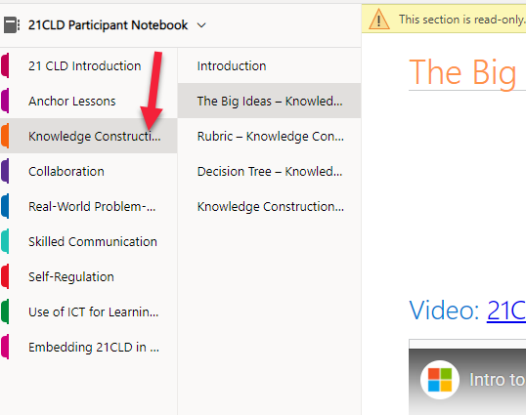
- Provide a link to an example of a learning artifact (an artifact is a tangible result of the student learning… how did they demonstrate what they learned) from a project/lesson/unit your learners completed using Microsoft tools (you will have to put the artifact somewhere where you can share with a URL). This could be a Sway of a portfolio, if you train teachers, maybe it is a lesson plan they put together after one of your trainings, if you teach students, it could be a video, a PPT, a word doc, a Sway, anything at all! You could even use screenshots to show what your learners did (please keep all learner names/faces/identifiable information out of what you share).
Please check your link to ensure that it isn't a private URL and can be accessed by the reviewers. A great way to check is to open an "in-private" or "incognito" browser window and try your URL. If you can see your content, then the reviewers will be able to!). __________________(URL)_______________________

- Describe what the artifact (the result of student learning) is to which you shared a link, how it demonstrated the desired learning objectives, and how Microsoft tools were a critical part of the learning. ___________________(500 character min/2000 character max)_______________________

- Share two examples of how you have supported both your own learning and the learning and growth of your colleagues. Describe the activities that you completed and led and how it resulted in better teaching and learning. ___________________(500 character min/2000 character max)_______________________

Resources and courses to help you prepare your nomination:
Start at the Microsoft Learn Educator Center and look for courses on tools you aren’t familiar with in the Office 365 learning path and support site on Teams!
- Office 365 Teacher Academy - Microsoft Learn Educator Center
- Support on breakout rooms in Teams

Also be sure to use http://support.microsoft.com/education to find direct instructions on how to use different tools.

About Accessibility Checker

Flipgrid
- Engage and Amplify with Flipgrid
- Beyond the Basics with Flipgrid
- Discover the Flipgrid Discovery Library

Other Teams
- Master Microsoft Teams for any learning environment
- Support.microsoft.com – Teams

Minecraft: Education Edition
- Minecraft: Education Edition: Teacher Academy

Microsoft Edge
- Enrich the learning experience in Edge browser
- Microsoft Edge Browser Features | Microsoft
- Top 10 Microsoft Edge Chromium features // Tips, tricks and NEW updates - YouTube

21CLD
- Learning Path – 21st Century Learning Design
- 21CLD guide notebook
  - Access the course OneNote notebook here

MakeCode
- Microsoft MakeCode
- Teach AP Computer Science Principles with the Microsoft MakeCode curriculum

